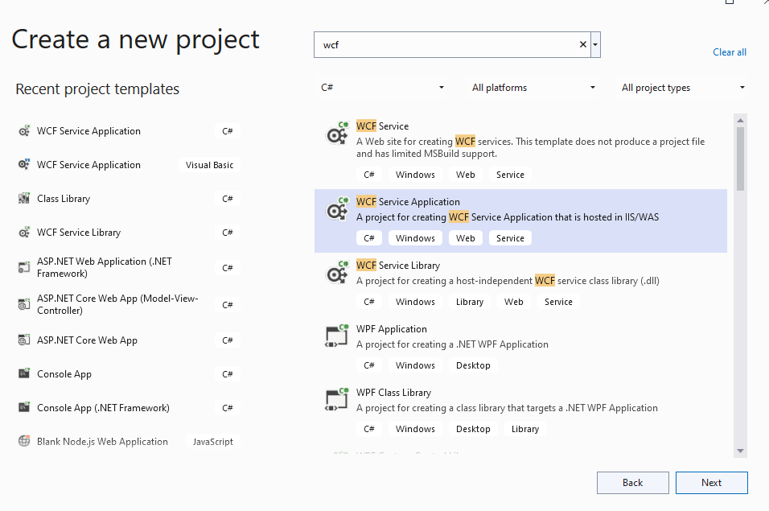
Click on next button
In solution explorer-> add new item->
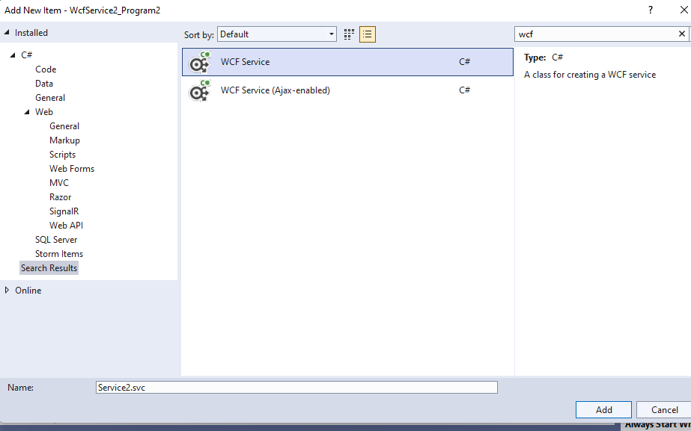
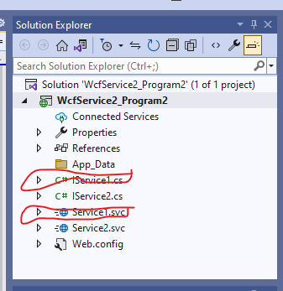
Delete IService1.cs and Service1.svc from solution explorer

Step 3: open IService2.cs
Add 2 method inside interface

[OperationContract]
DataSet selectdata();

[OperationContract]
int insertData(string name, string classname);

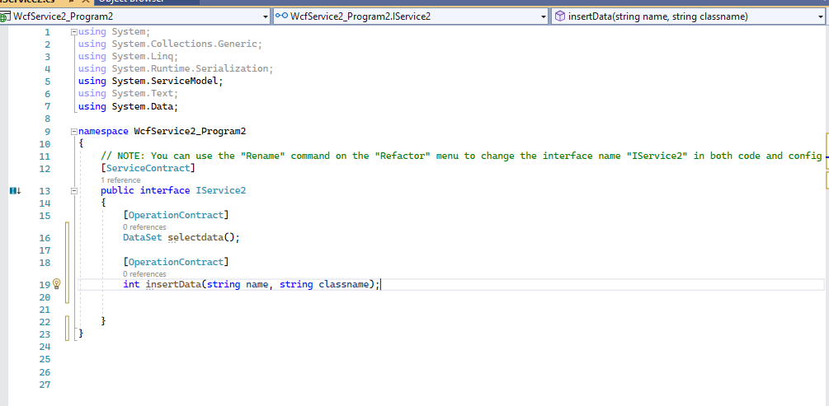
Step 4: IService2.svc
Implement the method of interface
Take the cursor IService2->click on implement interface

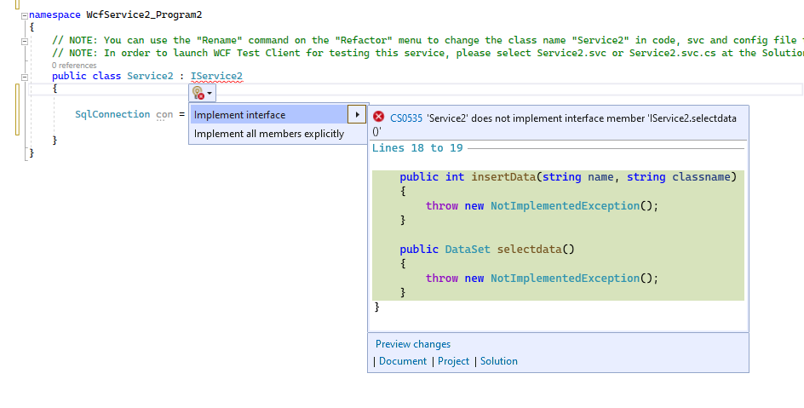
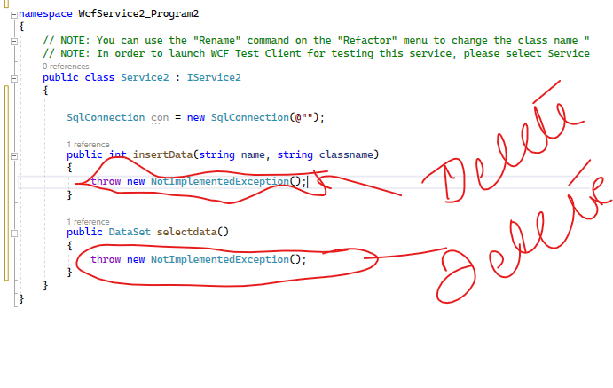delete the code inside this 2 method
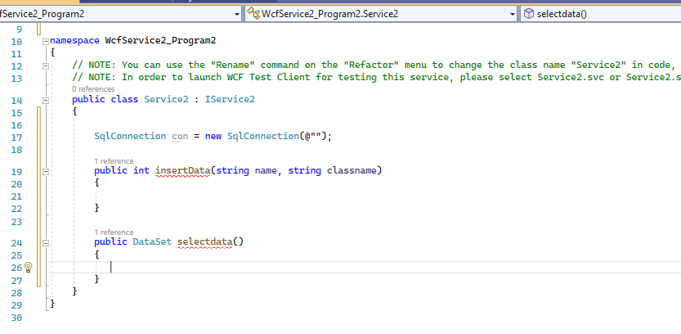
->>>Add the CONNECTION STRING

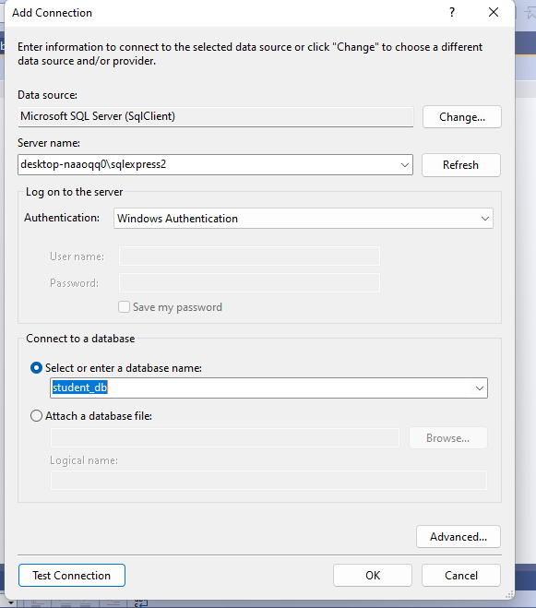
ADD SERVER NAME
SELECT THE STUDENT DATABASE
CLICK ON TEST CONNECTION
CLICK ON OK
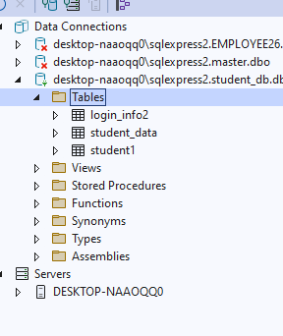
WE ARE GOING TO WORK WITH STUDENT_Data TABLE
CODE TO CREATE TABLE
CREATE TABLE student_data
(
[Id] INT NOT NULL PRIMARY KEY IDENTITY,
[s_name] NCHAR(10) NULL,
[s_class] NCHAR(10) NULL
)

GO TO SERVER EXPLORER
->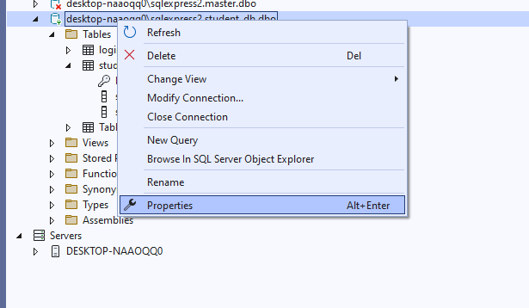
FROM PROPERTIES-> CONNECTION STRING->COPY THE CONNECTION STRING
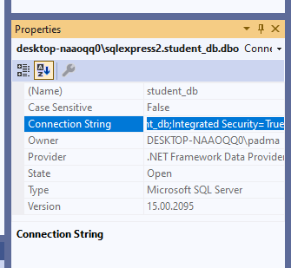

ADD THE CONNECTION STRING IN INSIDE Service2.sv.cs
SqlConnection con = new SqlConnection(@"Data Source=desktop-naaoqq0\sqlexpress2;Initial Catalog=student_db;Integrated Security=True);

code for selectdata() method
public DataSet selectdata()
{
SqlDataAdapter da = new SqlDataAdapter("select * from student_data", con);
DataSet ds = new DataSet();
da.Fill(ds);
return ds;
}

code for insertData() method
public int insertData(string name, string classname)
{
con.Open();
SqlCommand cmd = new SqlCommand("insert into student_data values('" + name + "', '" + classname + "')", con);
int res = cmd.ExecuteNonQuery();
return res;

}

Step 5:execute the IService2
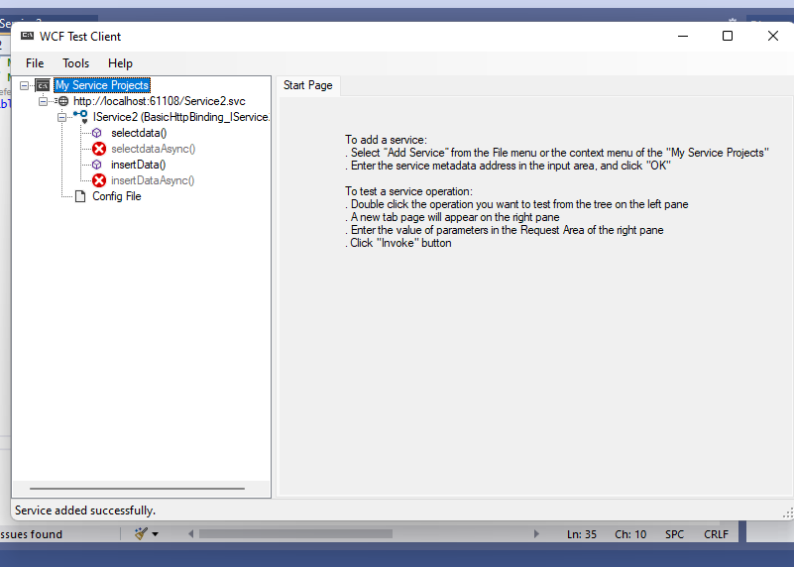
Step 6: add new project in the same project
Right click on solution->add->new project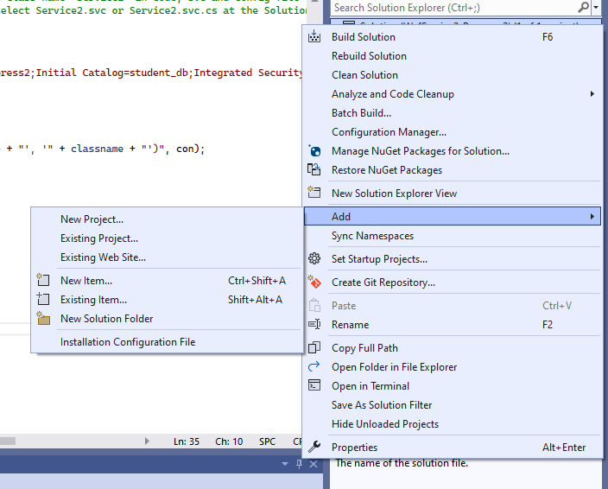
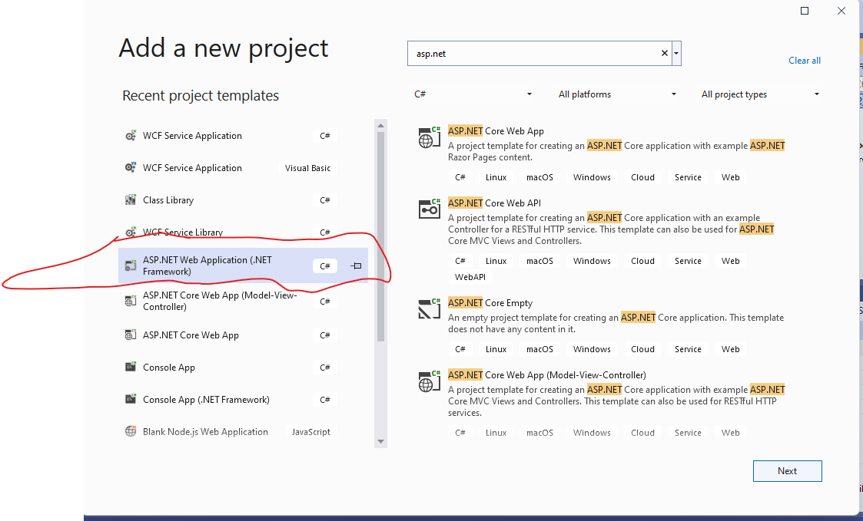click on Next button
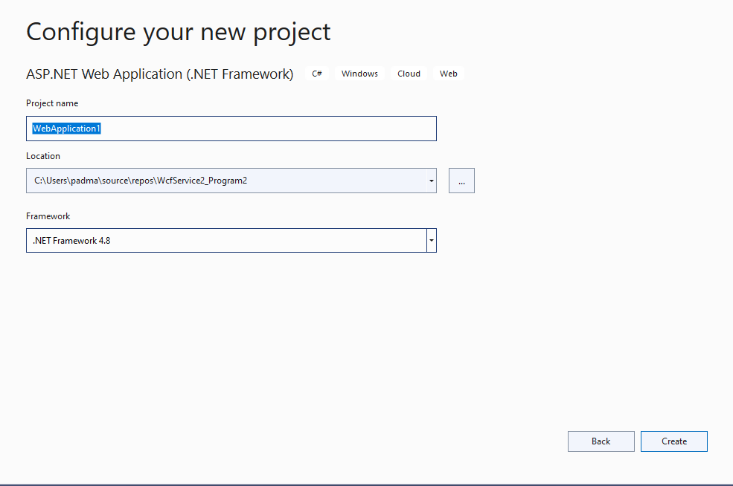click on create
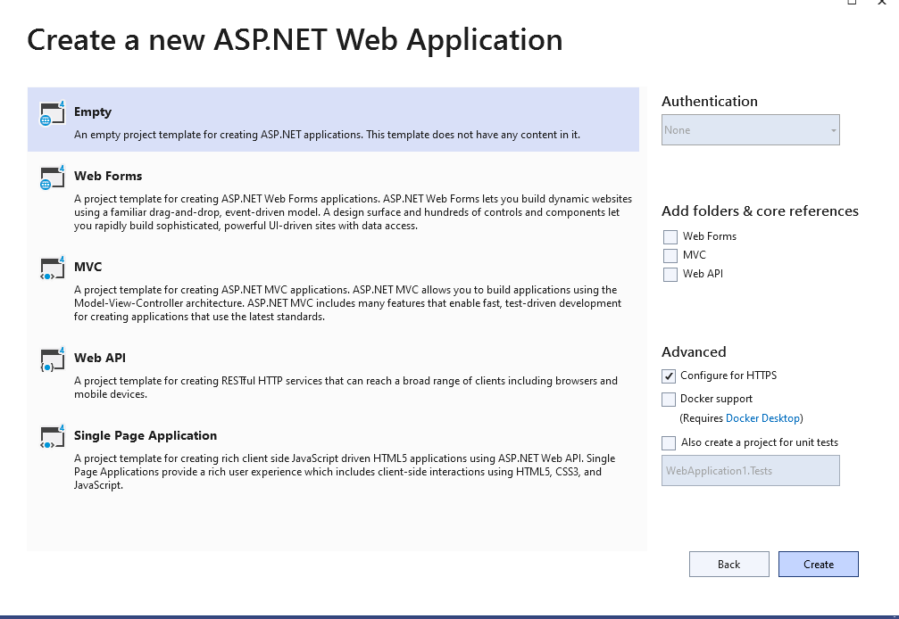choose empty->click on create
See below new WebApplication1 is added

Step 7:Add service reference

Right click on WebApplication1->add->service reference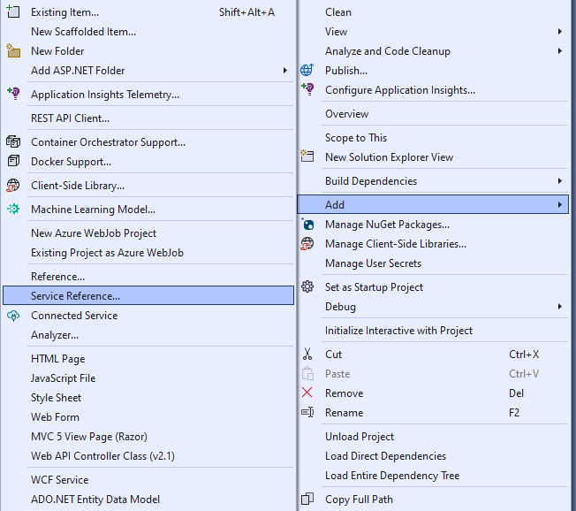
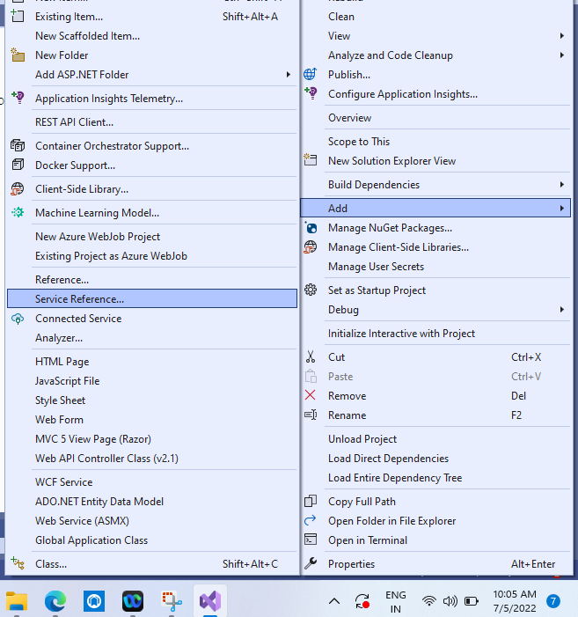

Click on discover-> then select service in solution
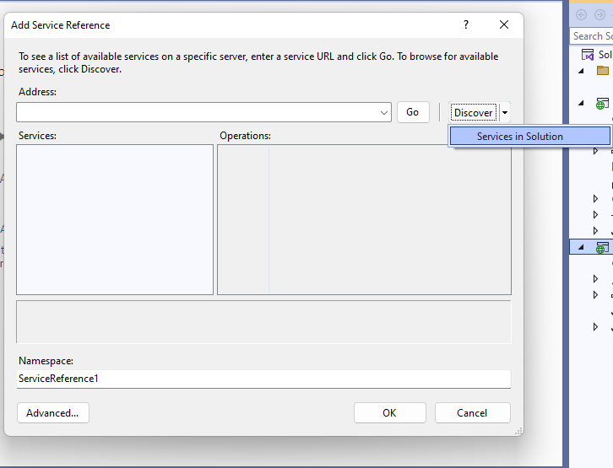
Select the service service2.svc
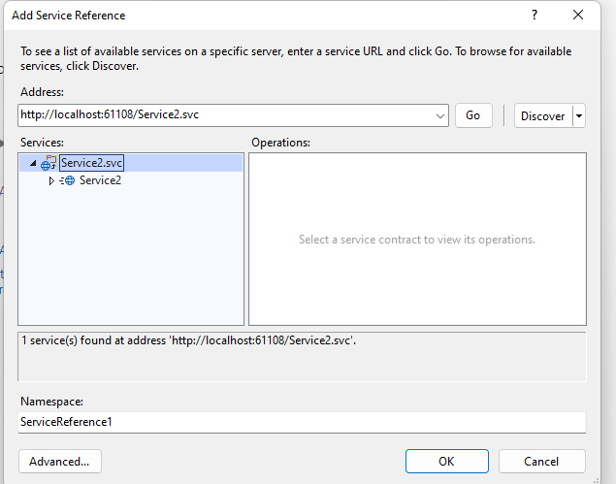click on ok button
In solution explorer you can check in side the WebApplication1 -> ServiceReference1 is added

Step 8:right click on WebApplication1-> Add-> New Item->WebForm1.aspx

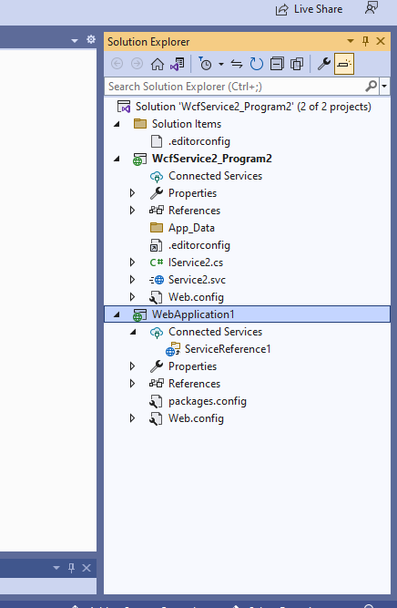

Design of webform1
<%@ Page Language="C#" AutoEventWireup="true" CodeBehind="WebForm1.aspx.cs" Inherits="WebApplication1.WebForm1" %>

<!DOCTYPE html>

<html xmlns="http://www.w3.org/1999/xhtml">
<head runat="server">
<title></title>
</head>
<body>
<form id="form1" runat="server">
<div>
<asp:GridView ID="GridView1" runat="server">
</asp:GridView>
<br />
<asp:Label ID="Label1" runat="server" Text="Student name"></asp:Label>
<asp:TextBox ID="TextBox1" runat="server"></asp:TextBox>
<br />
<asp:Label ID="Label2" runat="server" Text="Student Class"></asp:Label>
<asp:TextBox ID="TextBox2" runat="server"></asp:TextBox>
<br />
<br />
<br />
<asp:Button ID="Button1" runat="server" Text="Insert" />
</div>
</form>
</body>
</html>

Webform1.aspx.cs file add the code

using System;
using System.Collections.Generic;
using System.Data;
using System.Linq;
using System.Web;
using System.Web.UI;
using System.Web.UI.WebControls;

namespace WebApplication1
{
public partial class WebForm1 : System.Web.UI.Page
{
private ServiceReference1.Service1Client sc=new ServiceReference1.Service1Client();
private void BindGrid()
{
DataSet ds = new DataSet();
ds = sc.selectdata();
GridView1.DataSource = ds;
GridView1.DataBind();
}

protected void Page_Load(object sender, EventArgs e)
{
if (!this.IsPostBack)
{
this.BindGrid();
}

}

protected void Button1_Click(object sender, EventArgs e)
{
int res = sc.insertData(TextBox1.Text, TextBox2.Text);
if (res > 0)
{
Response.Write("Inserted");
}
this.BindGrid();

}
}
}

